Supplementary Figures
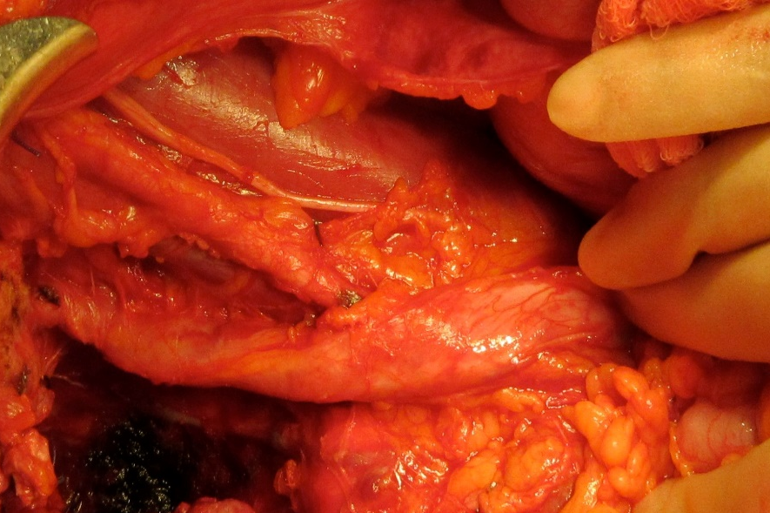
Figure 1A: Intra-operative trans-ureteric insertion of 6 French Bard® Silicone Ureteral Coil Stent (C.R. Bard Inc., Covington, GA, USA) through a longitudinal incision. A): Persistently dilated right ureter following extensive ureterolysis during cytoreductive surgery for recurrent ovarian cancer.

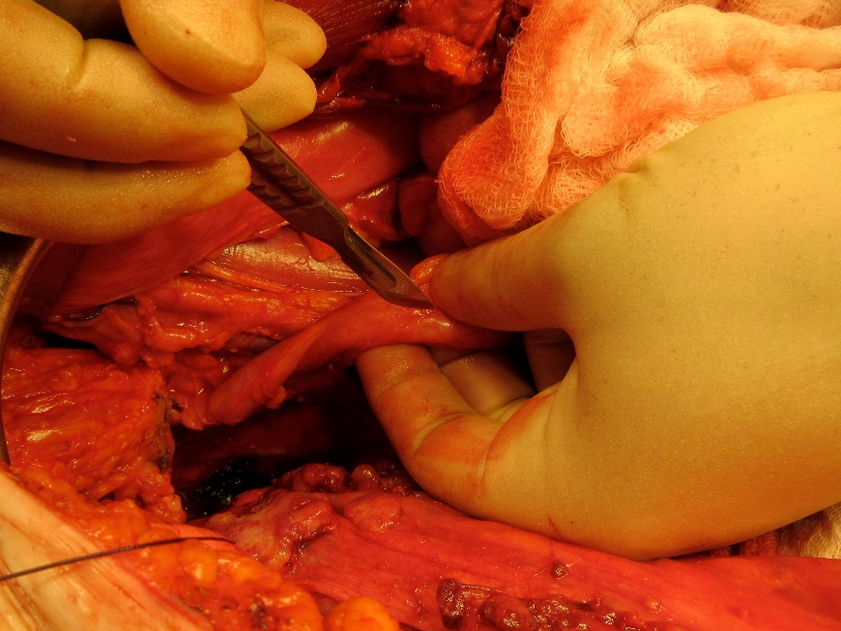
Figure 1B: Intra-operative trans-ureteric insertion of 6 French Bard® Silicone Ureteral Coil Stent (C.R. Bard Inc., Covington, GA, USA) through a longitudinal incision. B) 6 mm longitudinal incision is made on the anterior aspect.
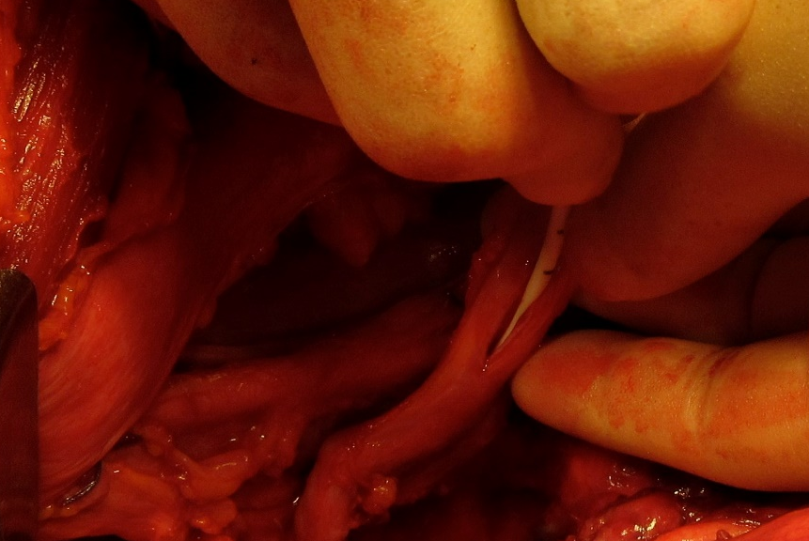
Figure 1C: Intra-operative trans-ureteric insertion of 6 French Bard® Silicone Ureteral Coil Stent (C.R. Bard Inc., Covington, GA, USA) through a longitudinal incision. C) Over a semi-rigid guidewire the stent is caudally and palpated to be correctly placed within the pelvic hilum before re-positioning the guidewire to insert the distal end into the bladder.

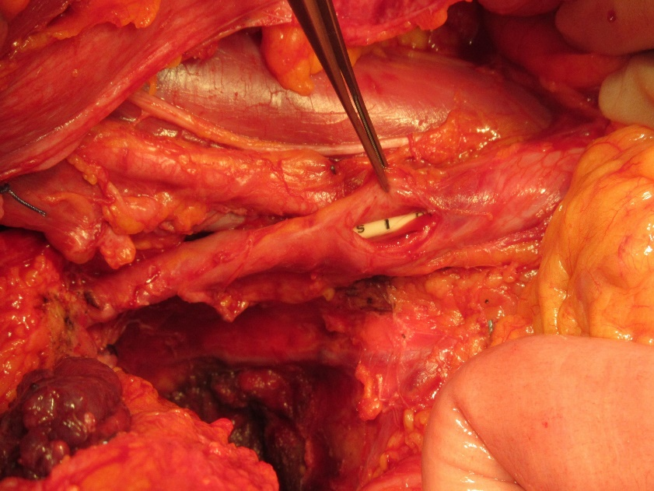
Figure 1D: Intra-operative trans-ureteric insertion of 6 French Bard® Silicone Ureteral Coil Stent (C.R. Bard Inc., Covington, GA, USA) through a longitudinal incision. D). The guidewire is removed to leave the stent securely held in position by the double pigtail ends.
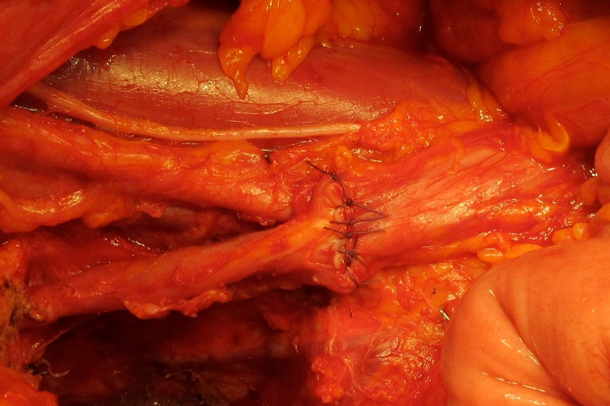
Figure 1E: Intra-operative trans-ureteric insertion of 6 French Bard® Silicone Ureteral Coil Stent (C.R. Bard Inc., Covington, GA, USA) through a longitudinal incision. E). Interrupted 3-0 vicryl closes the incision transversely, to avoid stricture formation.

